10.11.2021г. группа 1ТЭМ 2 подгруппа 4 пара
Дисциплина ОДБ.03 Иностранный язык
Преподаватель Романюта Маргарита Вадимовна
Занятие № 19
Модуль 6 « FOOD AND HEALTH»
Тема 6.2. Написание докладов. Экология, сельское хозяйство. Тест по материалу модуля 6.
Цели:
• Образовательная – расширение эрудиции студентов, их общего и лингвистического кругозора на основе практического овладения английским языком;
• Практическая–
1. Развитие навыков чтения, устной речи.
2. Совершенствование коммуникативно-познавательной компетенции студентов по теме «Экология, сельское хозяйство».
• Развивающая – развитие языковых, интеллектуальных и познавательных способностей студентов.
• Воспитательная – воспитание внимательного отношения к своему здоровью, привитие навыков здорового образа жизни, формирование общей культуры студентов.
Используемая литература:
1. Афанасьева О.В., Дули Дж., Михеева И.В., Оби Б., Эванс В. УМК «Английский в фокусе» для 10 класса, М.: Просвещение; UK.: Express Publishing: 2018;
2. Агабекян И. П., Коваленко П. И. Английский для технических вузов. Феникс, Ростов-на/Д, 2009.
Дополнительные источники:
- Ионина И., Саакян А. Английская грамматика. Теория и практика. – М.: Академия, 2008.
- Бережная О. О. Сборник новых тем современного английского языка. Донецк, 2009.
Справочники:
- Мюллер В. К. Англо-русский и русско-английский словарь. – М.: ЭКСМО, 2010.
Интернет-ресурсы:
- Портал по изучению английского языка.
Форма доступа: http//www.englishlanguage.ru.
- Сайты для изучения английского языка.
Форма доступа: http://www. study.ru – English Info
http://www.native-english.ru
http://www.study.ru
http://www.homeenglish.ru

1.Работа с лексикой
1.1.Прочитайте слова в словаре WL 19-20.
1.2.Запишите в тетрадь слова с транскрипцией.
2.Работа с заданиями на стр. 110.
2.1. Read the comments (A-E) . Which are positive and which are negative?
2.2. Read the rubric and answer the questions.
You work as a food critic for a magazine called Taste It. Your editor has asked you to write a report evaluating a new indoor area with restaurants and food stalls. Write your report, including information about the food, service, prices and atmosphere.
1 What is the aim of the report?
2 Who is going to read it?
3 Which of the following must you include in your report?
a size of area
b date it opened
с quality/type of food
d number of staff
e comments on atmosphere
f prices
g location of indoor area/food hall
h opening hours
i type of furniture
4. What style of writing should you use?
3. Грамматические упражнения.
3.1. Circle the correct word. Check in your dictionary. Then write a sentence with other word.
1. He had terrible stomach ache/pain after eating a kilo of blackberries.
2. The doctor gave him a prescription/recipe for some indigestion tablets.
3 There’s a terrible smell of rotten/sour eggs!
4 He was treated/cured for minor injuries.
5 Having a milky drink before bedtime can help cure/heal insomnia.
3.2. Fill in: from, in, with, against. Make sentences using the phrases.
1 Eating too much junk food can result ...... health problems later in life.
2 She often suffers...... bad headaches.
3 He’s in hospital recovering ......his operation.
4 Mike finds it hard to cope ...... pressure.
5 He advised me......eating too much sugar.
4.Работа с текстом на стр. 117.
4.1. Look at the pictures of the two farms in the text. Which is an organic farm and which a conventional farm? How do they differ?
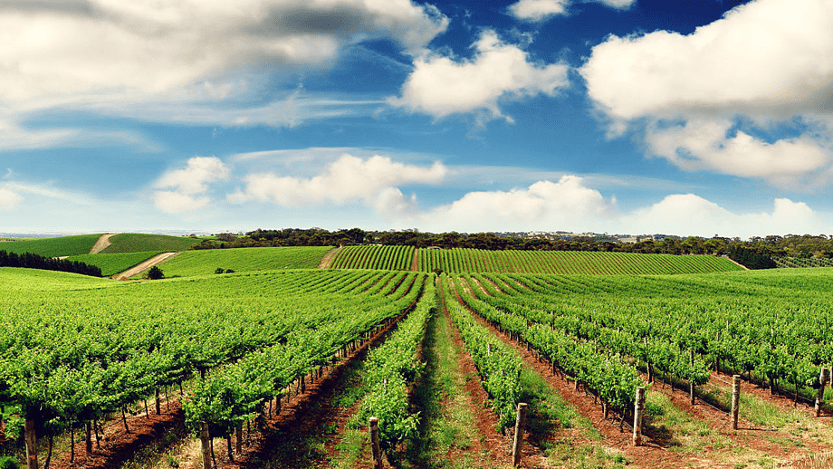
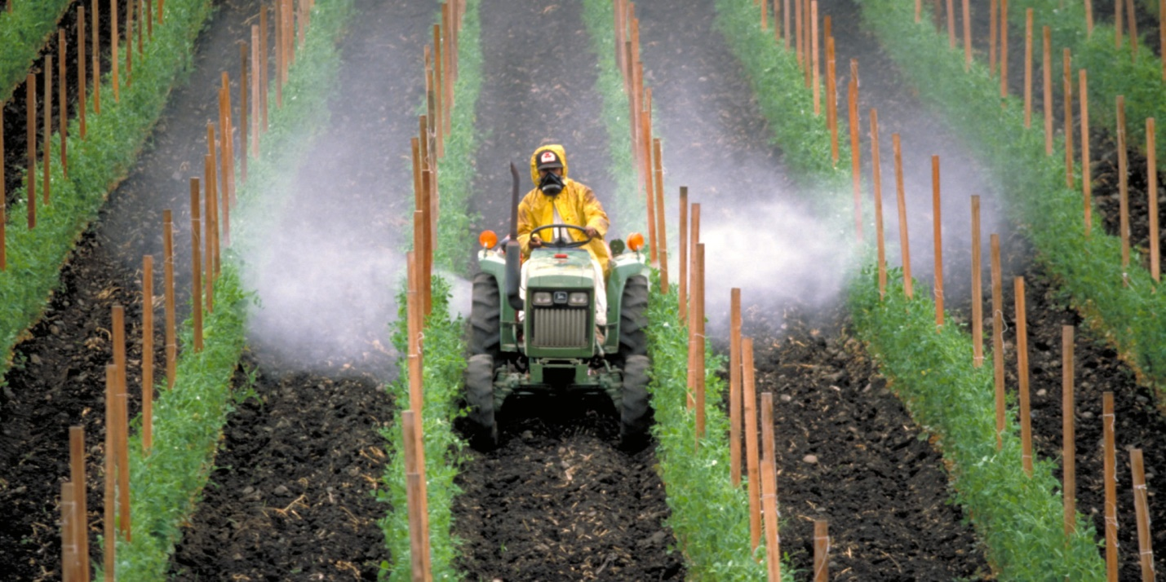
4.2. Read the text and complete the missing words.
Why organic farming?
Modern farming methods allow farmers to produce large amounts 0) of cheap food. There 1).............a cost to the environment, though, because intensive farming uses a lot of chemicals such 2)............... pesticides and fertilizers 3)................ damage ecosystems and destroy wildlife. It also uses a lot of energy because
4)................the amount of machinery used. Not only does the soil suffer from these methods, but the quality of the food is reduced, too. Organic farming, on 5)................other hand, aims to protect the environment while producing high quality food. Natural fertilisers such as manure and compost are used instead
6)................ man-made or chemical fertilisers. Organic farmers also use natural methods of pest control. They use ladybirds to combat greenfly 7)................burn
out by hand instead of using pesticides. They also use traditional farming methods such as rotating crops to different fields 8)........................year to maintain the nutrients in the soil. Organic food may be a bit expensive. However, it is healthy, tasty and better for the environment.
4.3. Answer the questions.
1. How can conventional farming be harmful to the environment?
2. Why is organic farming better for the environment?
Домашнее задание:
1.Письменно выполнить упражнения 3.2.; 4.3 данного занятия.
2.Выполнить тест по Модулю 6.
2.1. Fill in the correct word. Keep spices beetroot fight protect grapes feel complain greedy rumbling
1 Why do you always … about everything? Don't you like the food here?
2 Fruit and vegetables … us from all kinds of illnesses.
3 I am usually in a very good mood but sometimes I … down in the dumps.
4 He can't … his emotions under control; he gets angry very easily.
5 Make sure you eat a lot of arranges and kiwis; it's the only way to … off infections.
6 I'm making a fruit salad with apple, peach and …
7 The soup is very tasty. What … did you use?
8 Is there anything to eat? My tummy is …
9 Faye is so …; she sometimes eats a whole packet of biscuits without offering a single one to anyone else!
10 My favourite vegetables are broccoli, cabbage and …

2.2. Complete the sentences with the correct form of the verb in brackets.
1 If I … (not/have) to work tonight, I would come with you to the restaurant.
2 If only … (not/cause) damage to his car! He wouldn't be upset with me now.
3 I wish he … (stop) watching TV! He's been sitting there for four hours.
4 Until you tell me what is wrong with you, I … (not/leave).
5 If he … (not/study) harder, he won't pass his French exam.
2.3. Fill in with the correct preposition
1 You must give … this crash diet; it's not good for you.
2 Georgia suffers … stomach problems; she can't have any dairy products.
3 He's always very nervous about everything; he can't cope … stress at all.
4 The doctor advised me … fatty foods.
5 What are you cooking in there? It's giving … a nasty smell!
Срок выполнения задания до 15.11.2021.
Все работы выполнять в рабочих тетрадях, фотографировать и отправлять на адрес преподавателя Романюты М.В. rita.romanyuta@mail.ru

